HTML Basics
Day 1
Task 1 (Create a basic HTML page with title "My Website")
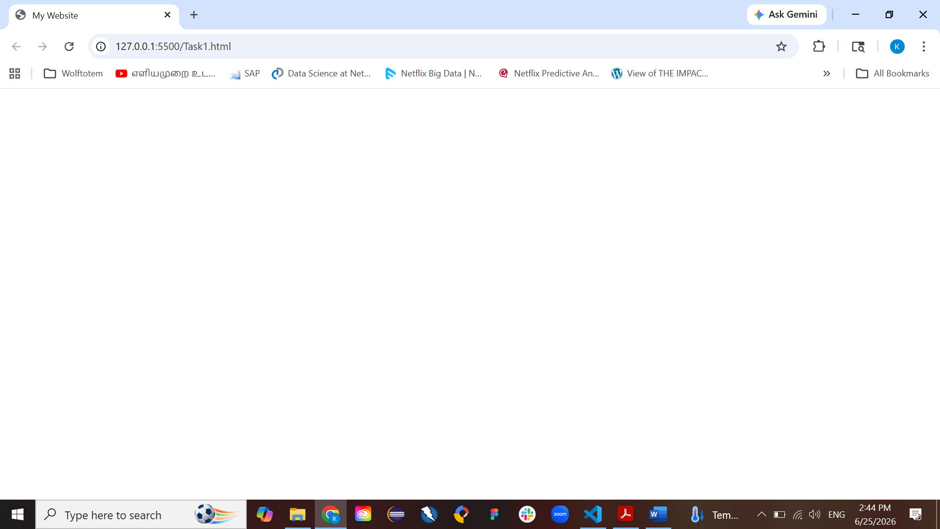
Task 2: Display a heading ("Welcome to Web Development")
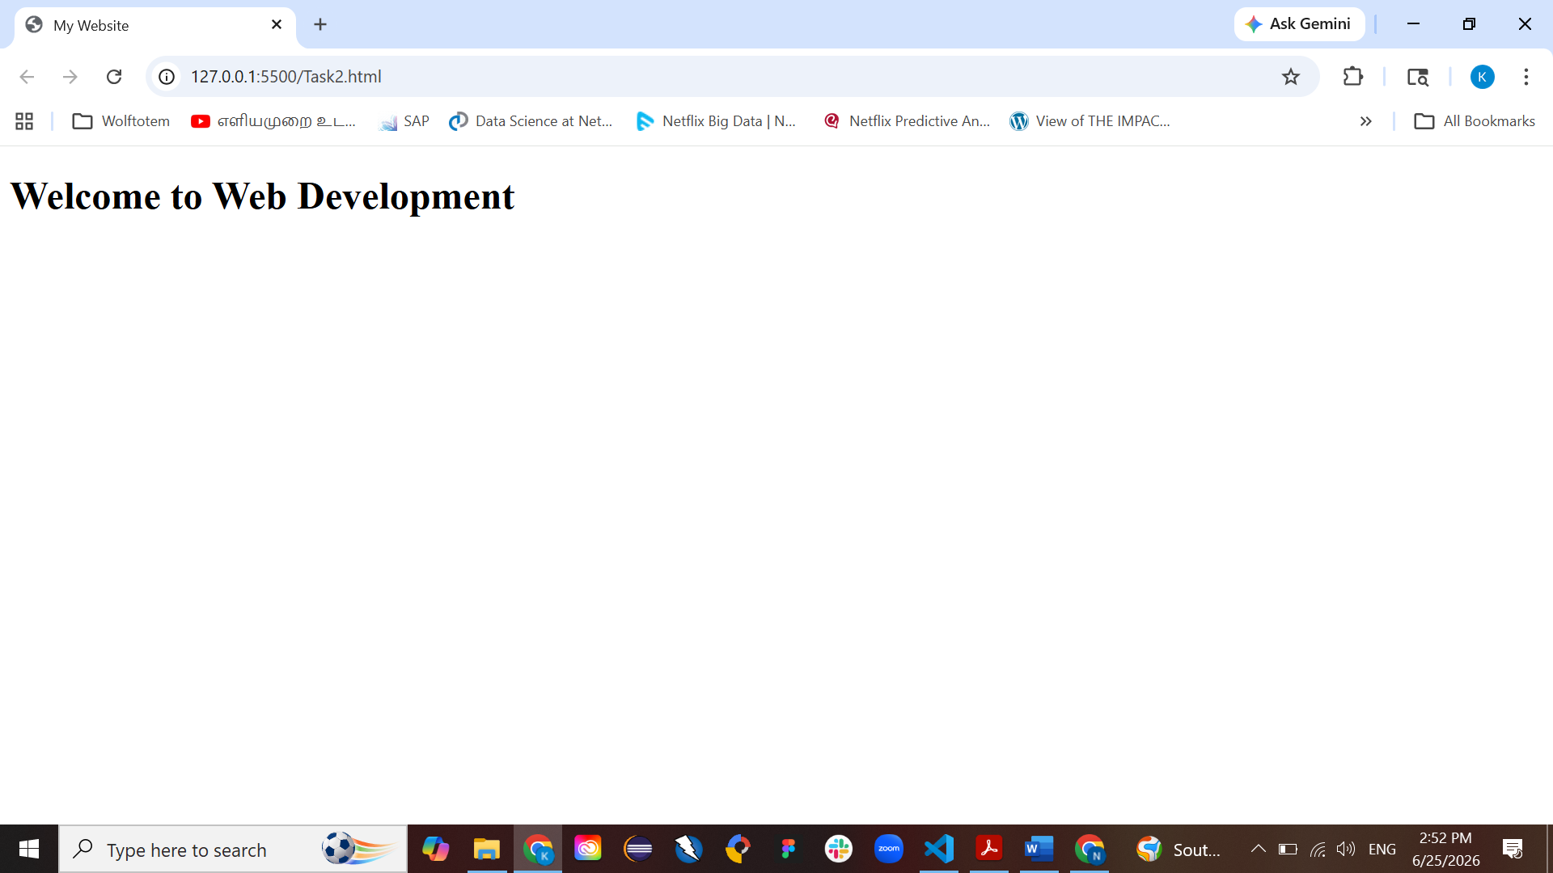
Task 3: Add a paragraph about yourself
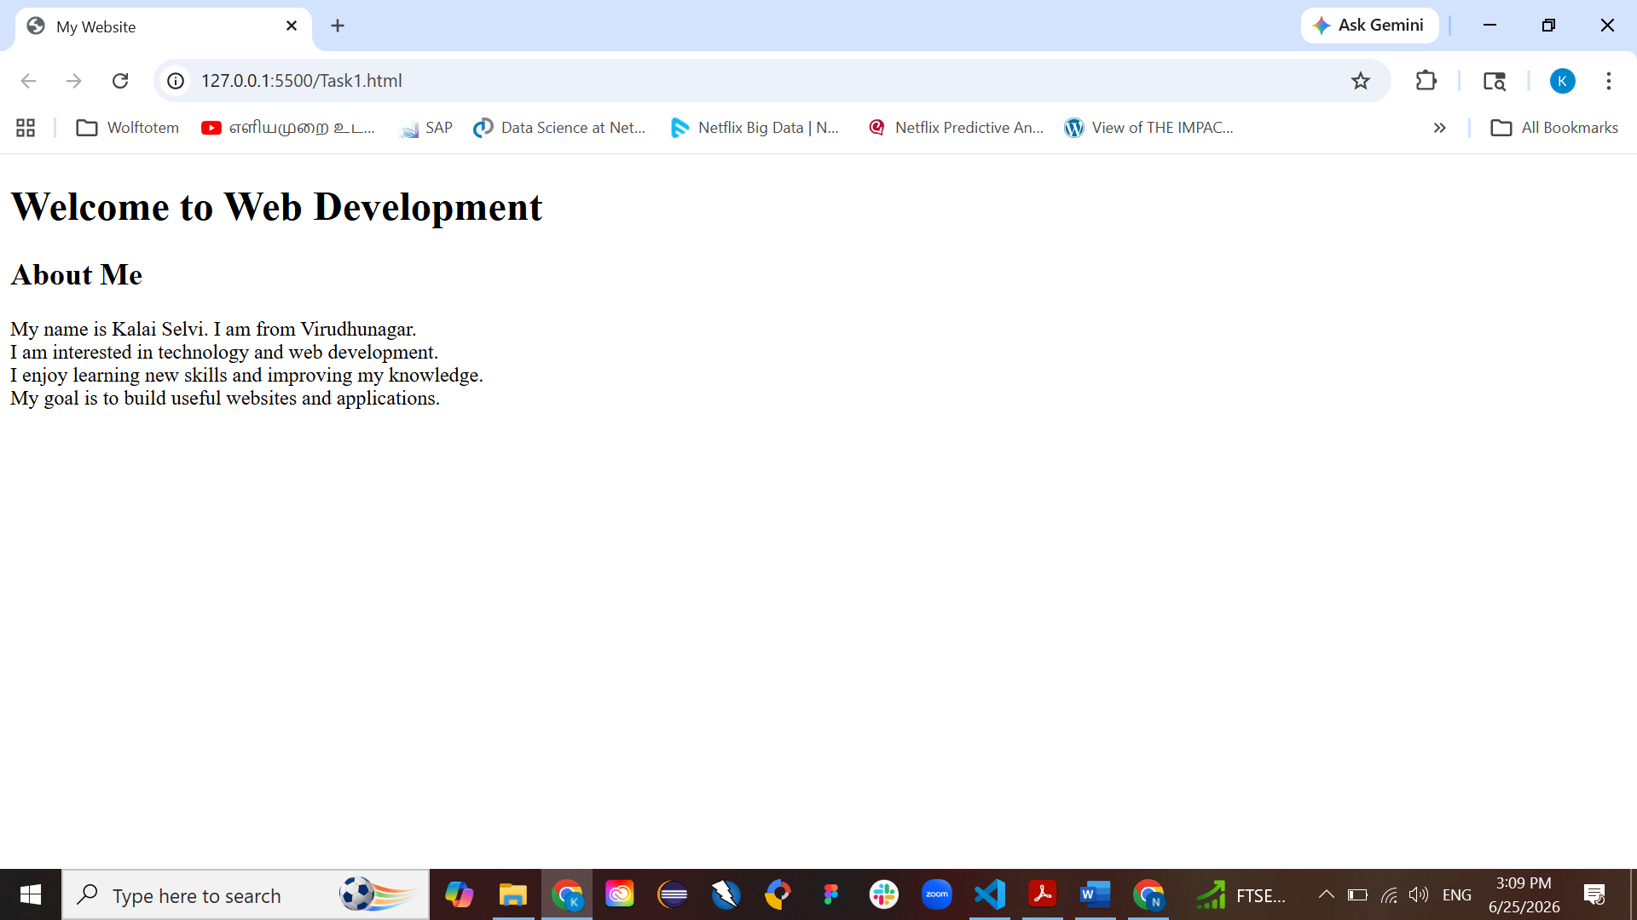

Task 4: Create a page with h1, h2, and p tags
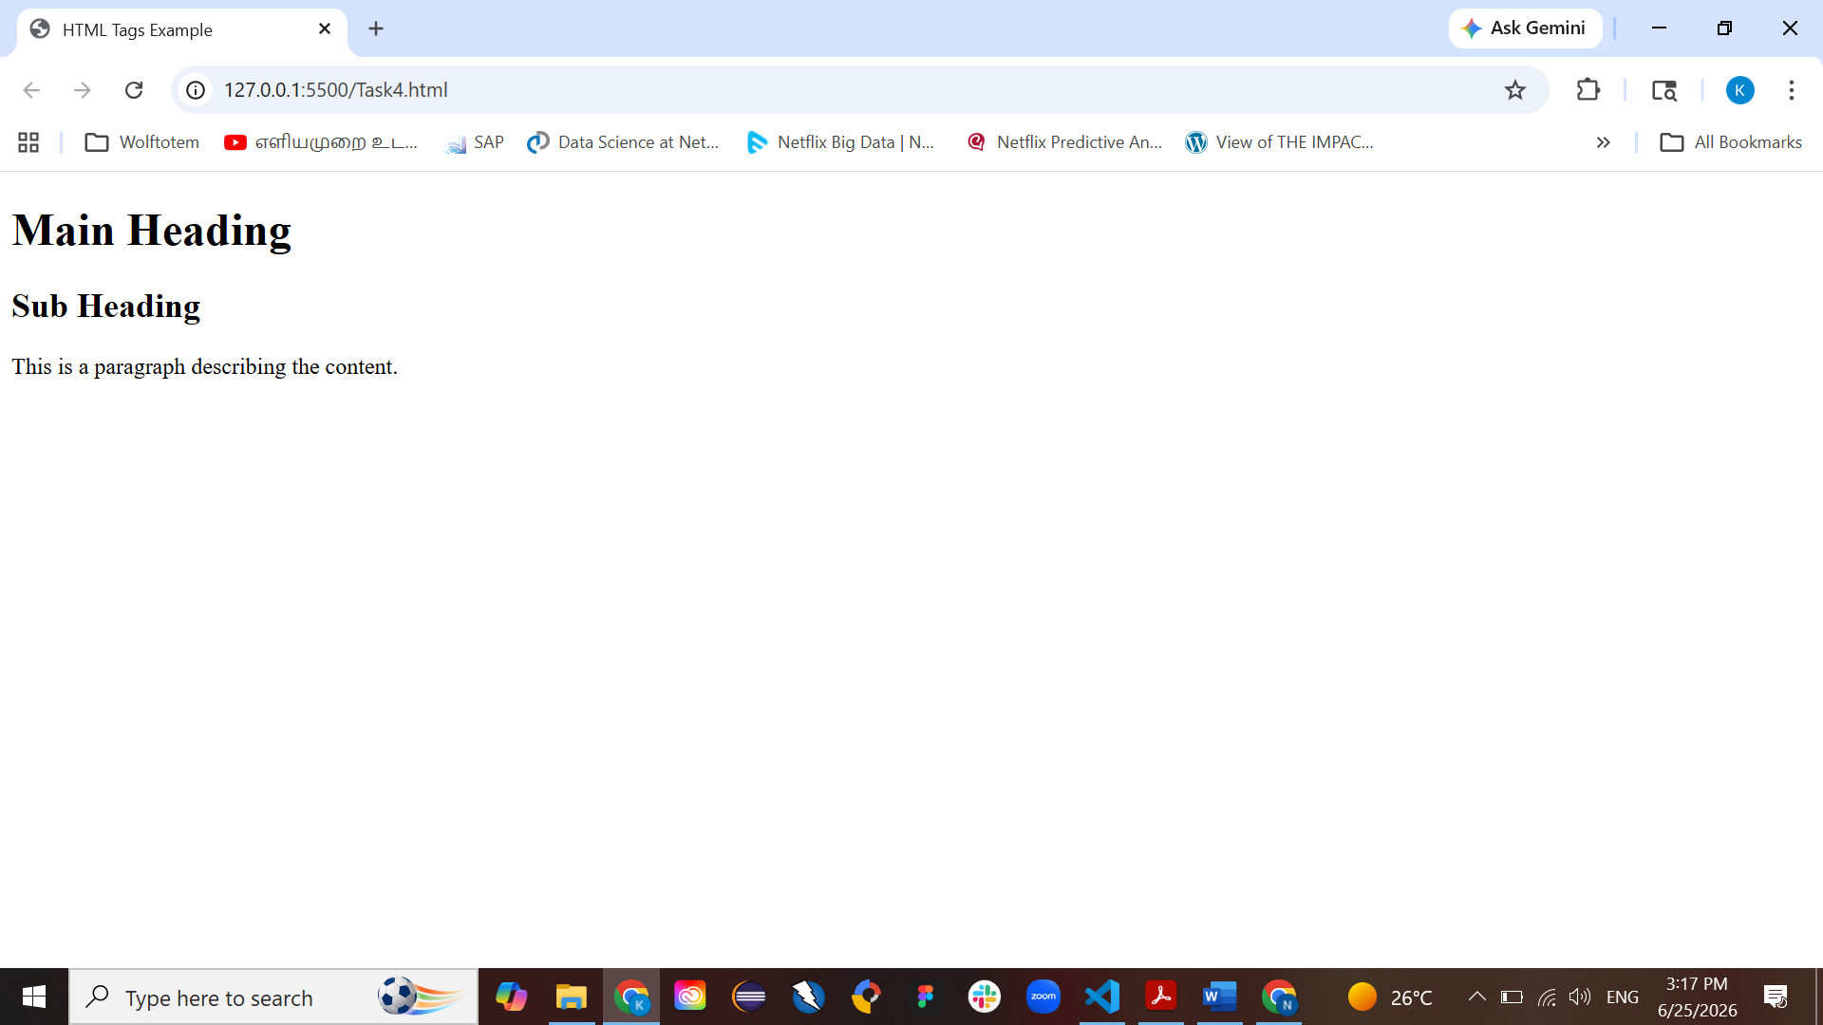
Task 5: Create a webpage showing Your name, Your course, Your college/company
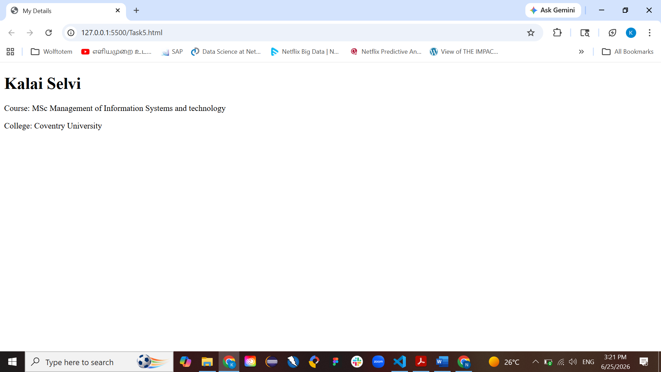
Task 6: Create a page with a title "Client Server Model"
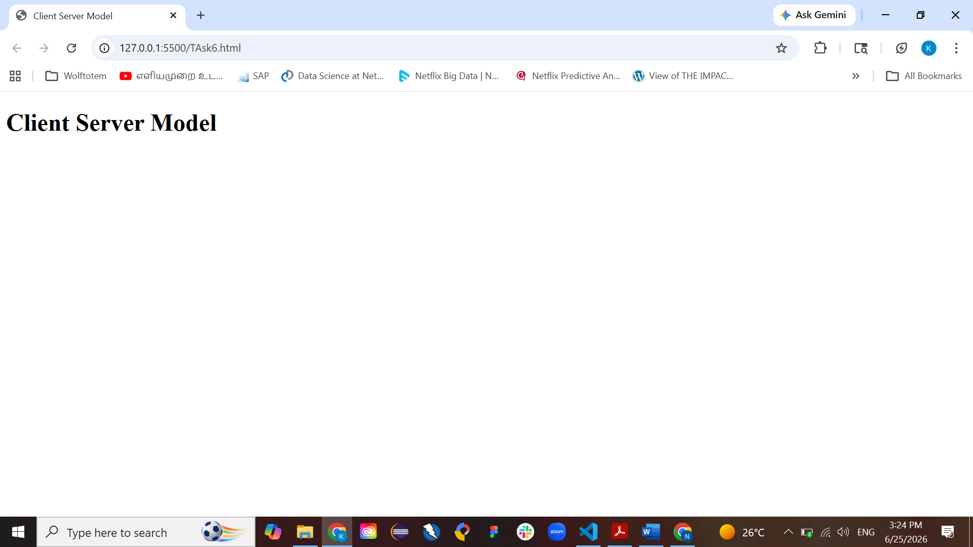

Task 7: Write a simple explanation of HTML inside <p> tag
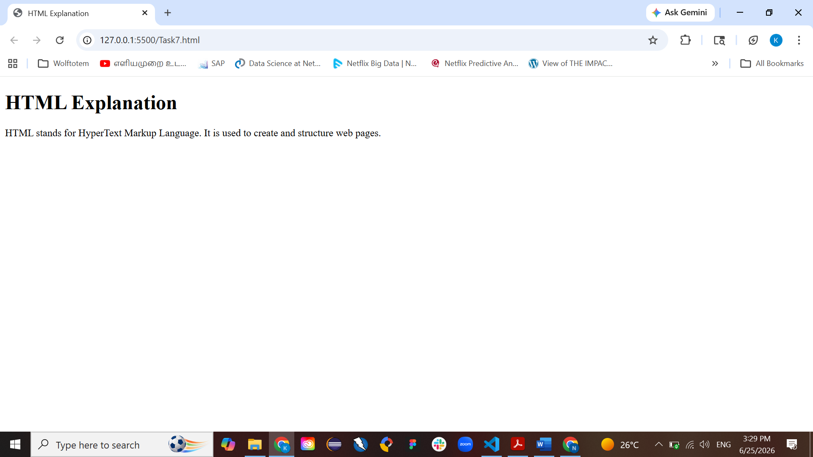
Task 8: Create a structure using: html, head, body, title
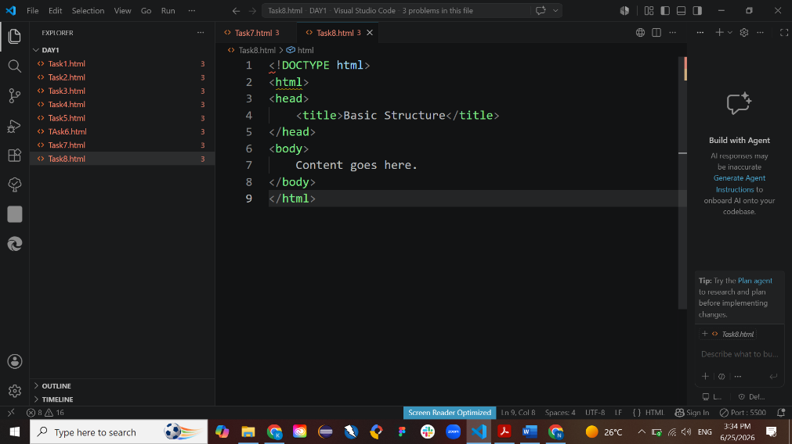

Task 9: Hello World Webpage
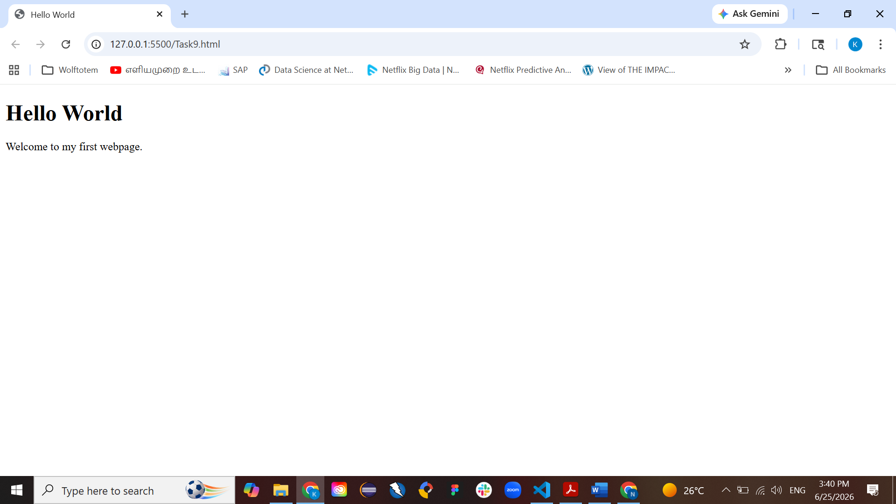

Task 10: Mini Profile Page
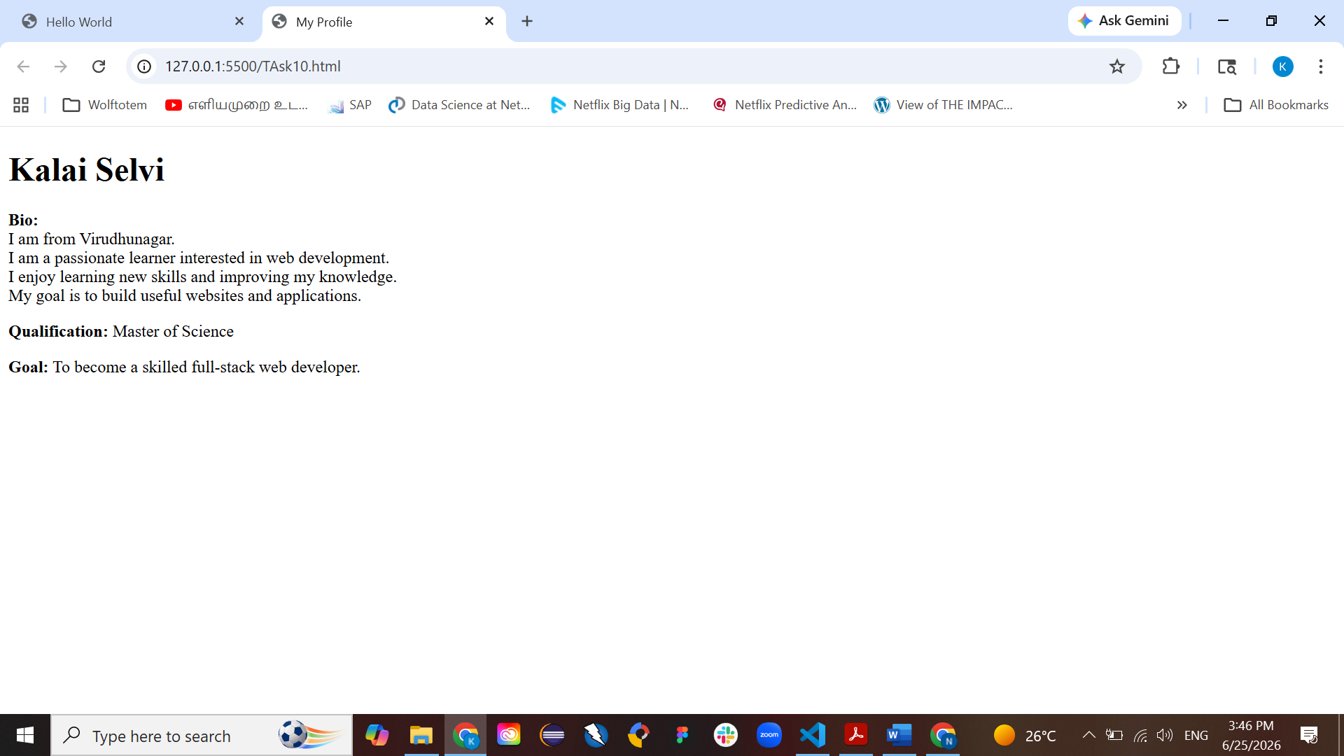

Project 1: Simple Profile Page
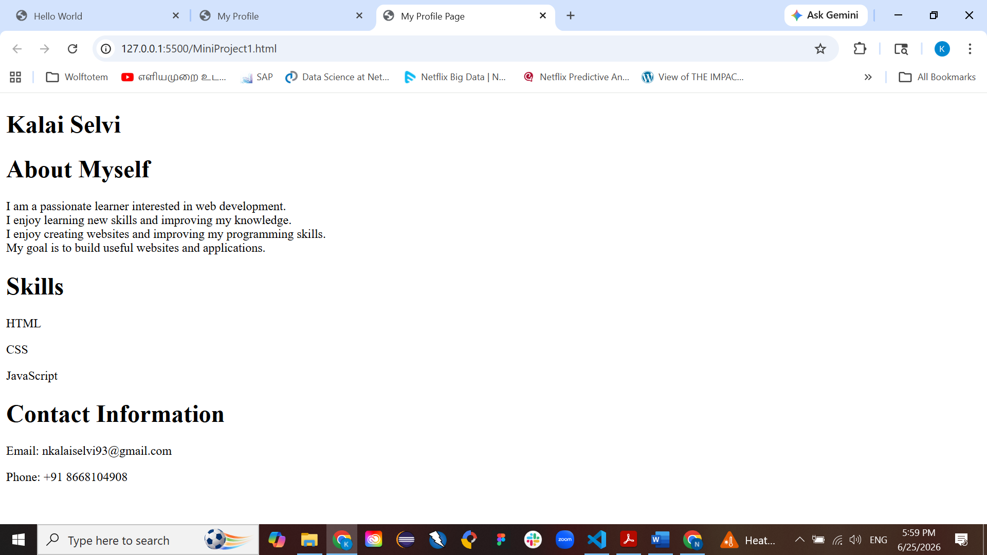
Project 2: Web Development Info Page
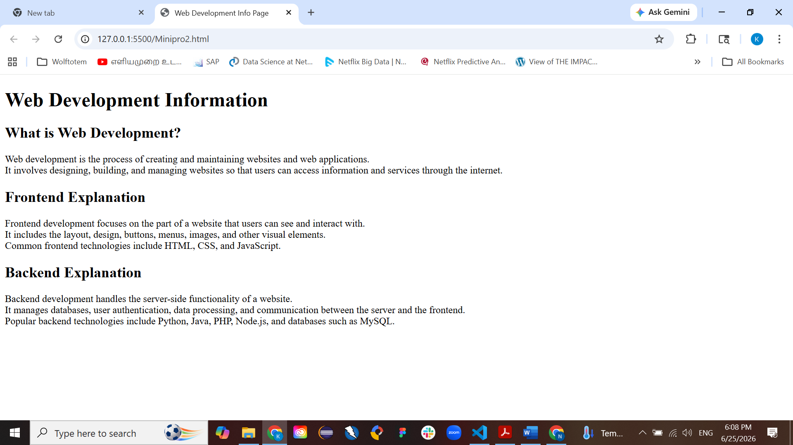
Project 3: Student Information Page
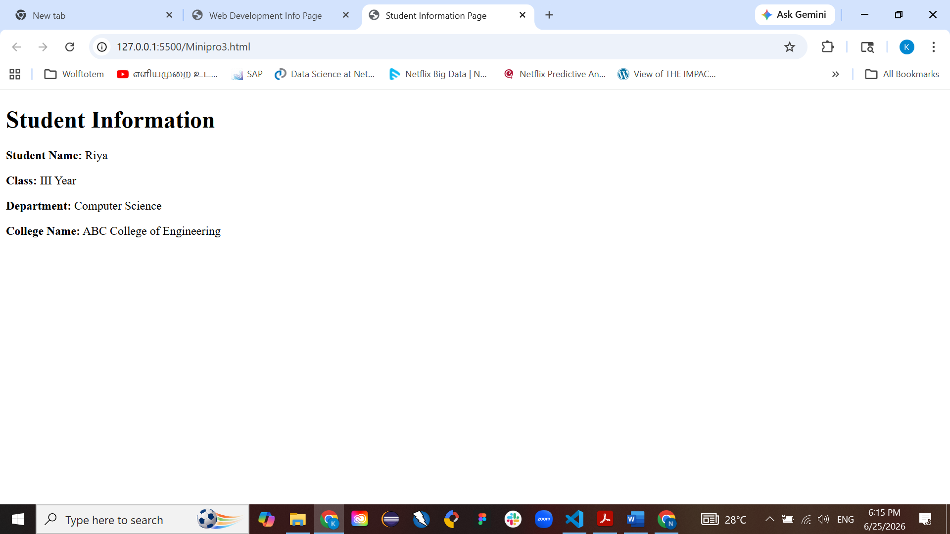
Project 4: Basic Article Page
